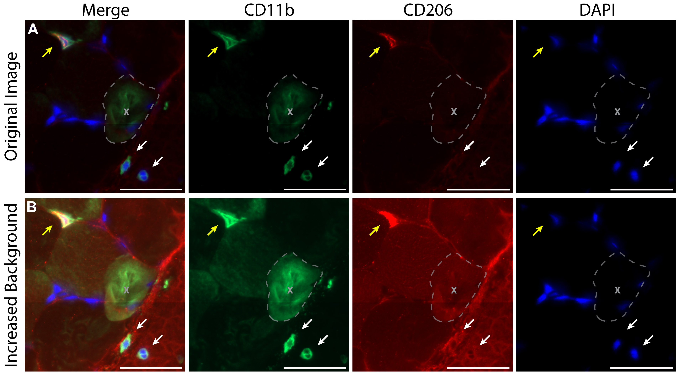
Figure S1. Images showing a bubble underneath a skeletal muscle section. A. The original image prior to display adjust. The grey outline is demarcating the borders of the bubble. Yellow arrow points to a CD11b+/CD206+ macrophage and white arrows point to CD11b+/CD206- monocytes located in a blood patch (Figure 5, panel B). B. The same image with the display adjusted to make background staining more visible, clearly showing the bubble present underneath the tissue section.

